Rubric: UNIT: FUTURE OF NATURAL RESOURCES
ALGEBRA 1: Criteria D Applying Mathematics in Real-Life Contexts
7-8 Identified relevant elements 5 & reached a correct solution using adequate strategies. Described correctly with explained accuracy.
5-6 Identified relevant elements &
4 reached a valid solution using adequate strategies. Stated correctly and described accuracy in real-life.

3-4 Identified relevant elements 3 & reached a solution. Stated but not always correct solution that makes sense in real-life. ituations.
1-2 Identifies Some real-life
1-2 elements and limited success to find solution to authentic real-life situations.
0 No Standard
0 Reached
No Attempt made
Level 3
Grade
Concept

Special projects
Cover Sheet
Outside information

Answer: Cover Sheet: John Doe, P-1, Seat 39, “Future of Coal”. Cover sheet has picture of natural resource. Attached 3 or more website Addresses or other data references. Hardcopy proof of all data used and the data highlighted with reference easy to find. Data recorded correctly and neatly from references.

Linear equation of usage rates from research results using >5 years of data. Total amount of natural resource is world total & within the last 15 years. Verifiable amount of total amount and usage rate. Process write up vertical format (DM) on one sheet—easy to follow. Calculations of usage rate and depletion by year until 2060 in table.

Introduction paragraph on choice of Natural Resource.

Process write up with equation(s).

Graphs
Charts or Tables

Write Up Conclusion.

I chose Coal! When I first read the project, I was very excited and knew that I was going to do coal. My father works for the coal company and I wanted to see if I should follow my father into this field of employment. I will learn how to properly do research and find out if there will be coal remaining… world when I get to be 63. Based on current and projected coal usage rates, how much coal will be….

Answer: 480≤x≤520 words, Power-ful , insightful write up with embed-ded graph referenced. “intensive research via the internet and personal interview with…found the current.. Through a vigorous process of calcul -ations, using the slope creating linear equations using rise and run, the current rate of natural resource usage is...” The future

Graph has beginning and ending values. Multiple equations & R² ’s
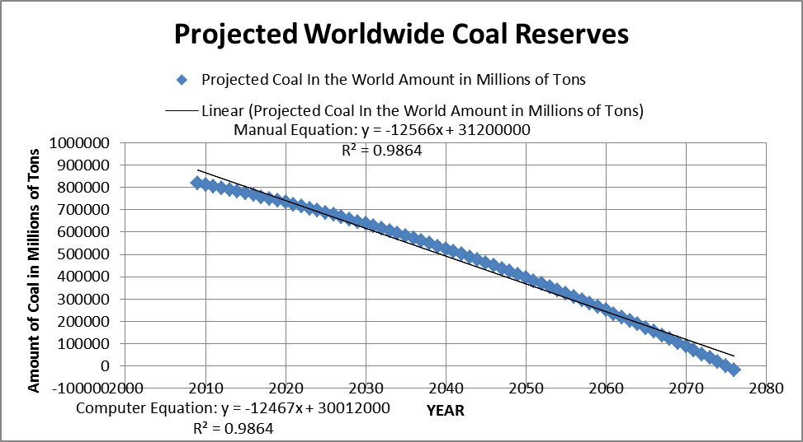

Answer: Cover Sheet: John Doe, P-1 Seat 39, Coal. Attached 3 website Address(s) http://www.eia.doe.gov/ oiaf/ieo/coal.htm. and Web Site hard copies: Had 3rd web site listed with limited hardcopy proof of data. Data recorded correctly from sites.

Answer: Cover Sheet: John Doe, Seat 39, Coal. Attached only 2 website Address(s) http://www.eia.doe.gov/ oiaf/ieo/coal.htm. and Web Site: Had 3rd web site listed but no hardcopy proof of data. Data recorded correctly from sites.

Answer: Cover Sheet: John Doe, Coal. Attached only 1 (or 2) website Address(s) http://www.eia.doe.gov/oiaf/ieo/coal.htm. Recorded incorrectly data from site or data bogus from reference. No or 1 hardcopy data from reference.

Answer: I was very excited and knew that I was going to do the amount of coal in the world & how long it will last. The topic or coal really interested me because I have heard we are running out of other fuel resources and our savior will be coal . How much coal will be in the world in the year 2065 & will the human race find alternate…

Linear equation of usage rates from research results using 5 years of data. Total amount of natural resource is world total & within the last 15 years. Verifiable amount of total amount and usage rate. Process write up vertical format on one sheet—easy to follow. Calculations (single method) of usage rate and depletion by year to 2065.

Answer: 480≤x≤520 words. Strong write up with embedded graph. “search of two source found 5 data points each for the amount of resource and rate of usage, plotted each point on a graph. The current rate of usage is shown by the slope (shown on graph) of the natural resource…” While the amount of resource today is…,In the year 2065, .

Graph has beginning and ending values. Manual and Computer(R² ’s)equations.
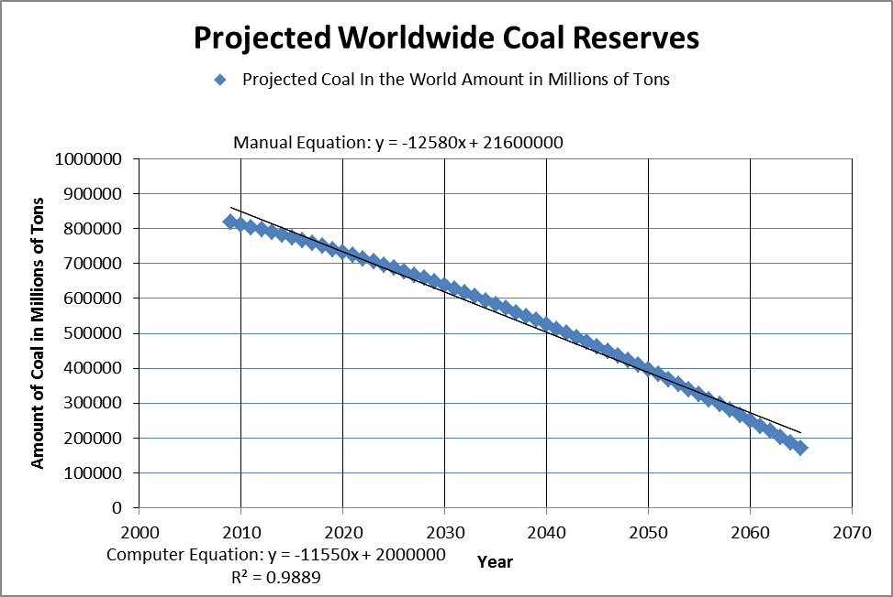

Answer: When I got this project, I thought it would be exciting to find out the amount of coal in the world & how long it will last. The topic or coal really interested me because I have heard we are running out of other fuel resources and will be using coal. I think this will be a fun and rewarding project that will teach me how to do research. Problem statement: How much coal will be in the world in 2060 based on.

Answer: Linear equation of usage rates from research results using 4 or 5 years of data. Total amount of natural resource is world total & within the last 15 years. Verifiable amount of total amount and usage rate. Process write up neat and easy to follow. Calculations of usage rate and depletion rate by year until 2065 clearly written.

Answer: has beginning and ending values. One linear equation.

Answer: 480≤x≤520 words. Complete write up with embedded graph. “search of internet found 5 data points each for the amount of resource and rate of usage, plotted each point on a graph. The current rate of usage is shown by the slope (shown on graph) of the natural resource…” While the amount of resource today is…,In the year 2065, the amount...

Answer: <480 or >520 Words. Graph not correct and/or not embedded in write up. “found 5 years of data, did calculation, made a graph as shown, natural resource is good today and bad in the year 2065…..”

Construct 1 or more correct table and graph. Answer: Mislabeled or incorrect graph.

Calculate linear equations(s) from research using past history points for usage rates & apply to total amount of natural resource. Answer: Calculate linear equation of usage rates from research results using ≤ 2 sources or ≤3 years of data. Total amount of natural resource not world total or not within the last 15 years. Bogus amount of total or bogus usage rate. Write up difficult to follow.

Answer: I was assigned this project and decided to do coal because the teacher already had given me some references on coal.

Write down: NO: Name, Project Name, class period, & seat # on cover sheet. Information on natural resource and consumption rate…
Answer: ? Blank
Don’t Know

Summarize the process with beginning and ending results with a personal reflection of natural resource to the year 2065. Slopes. Answer: ? Blank Don’t Know.

Construct 1 or more table with the correct columns and build a graph of the current and proposed Slope of the Bank. Answer: ? Blank Don’t Know.

Calculate linear equations(s) from research using past history points for usage rates & apply to total amount of natural resource. Answer: ? Blank. Don’t Know

Introduction paragraph on natural resource.
Answer: ? Blank
Don’t Know

